FSD: Lab Guide-Phase 3

This section will guide you to:

* Use practice labs to execute demos in the course

This lab has two subsections, namely:

1. Starting practice labs on LMS
2. Using different IDEs and software required for Phase 3

**Step 1: Starting Practice Labs on LMS**

* Login to Simplilearn LMS
* Navigate to the respective course and click on it.

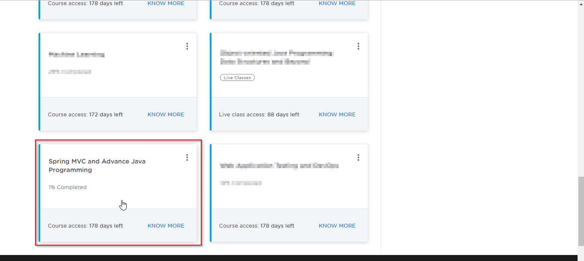

* You will see the course table of content on the left side of the screen. Below the **SELF LEARNING** tab, you will find the **PRACTICE LABS** tab. Click on it.

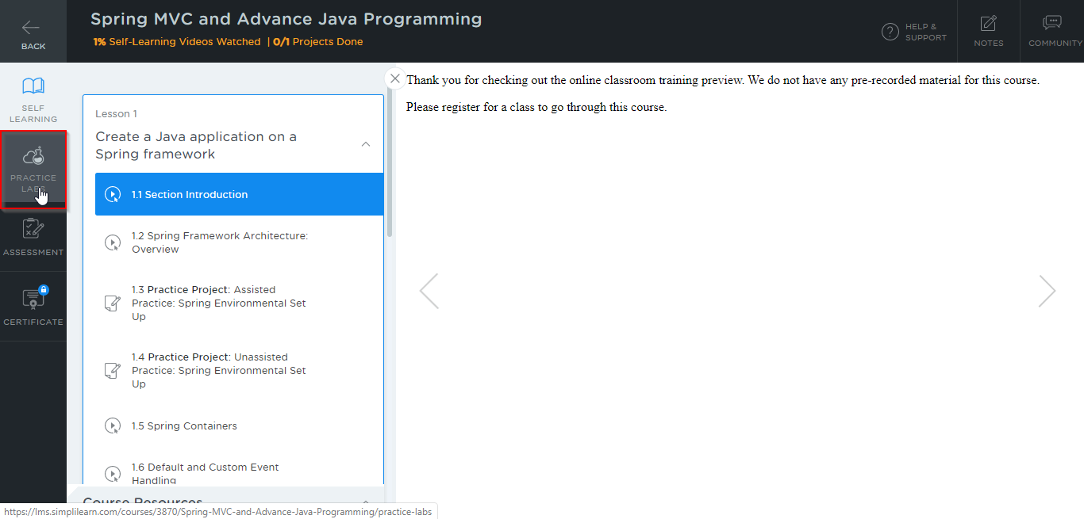

* A new window will open. Go through the instructions and click on **LAUNCH LAB**. This will launch the practice labs for this course.

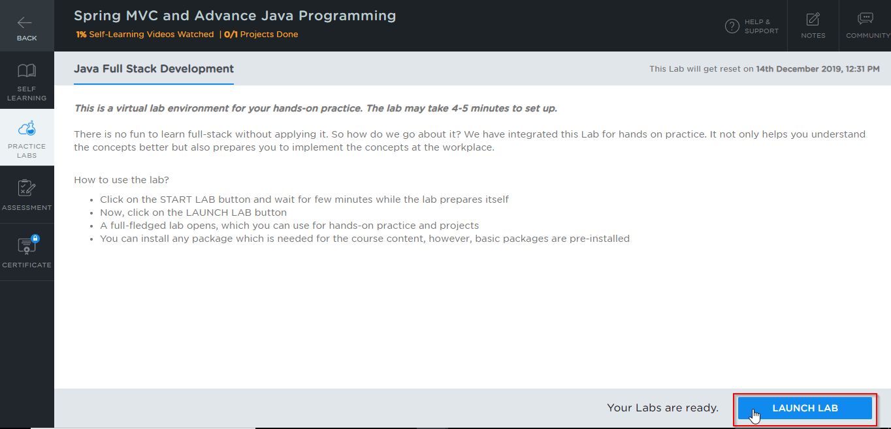

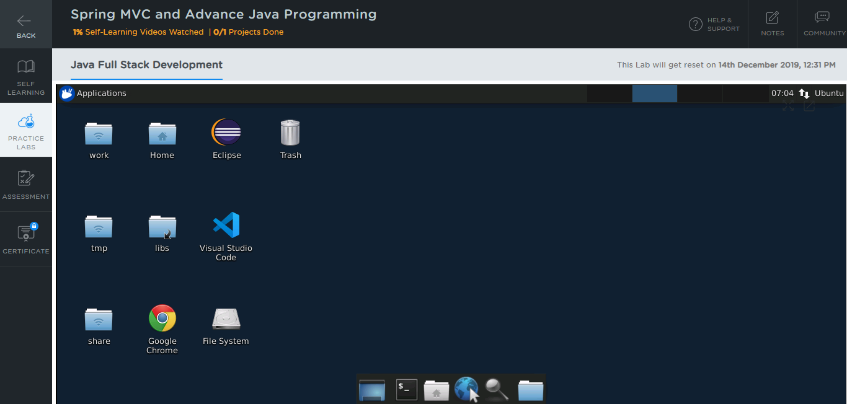

**Step 2: Using different IDEs and software required for Phase 3**

All the required IDEs and software can be accessed from the lab.

**Spring Tool Suite & Spring Boot:**

* Spring and its packages are already installed in your practice labs.
* To verify the installation:

1. Open your eclipse environment from the desktop.
2. Go to the **Help** tab and select **Install New Software.**

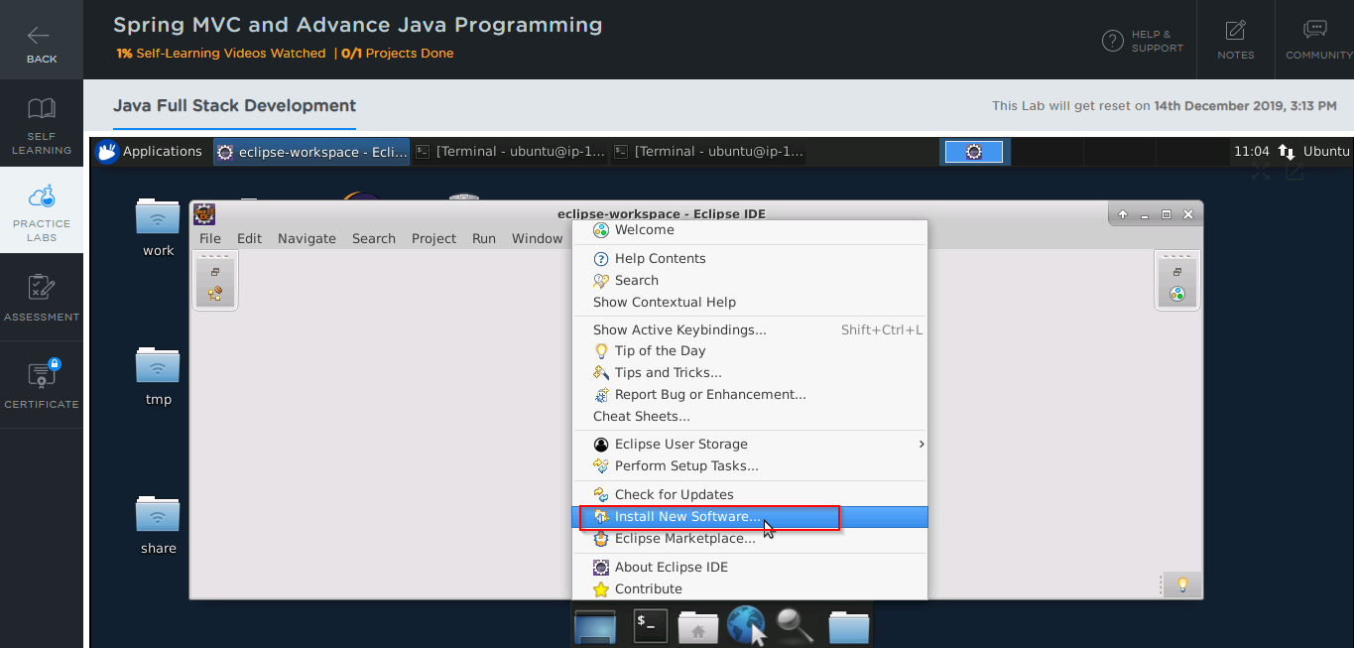

1. In the next window, click on **Already Installed**.

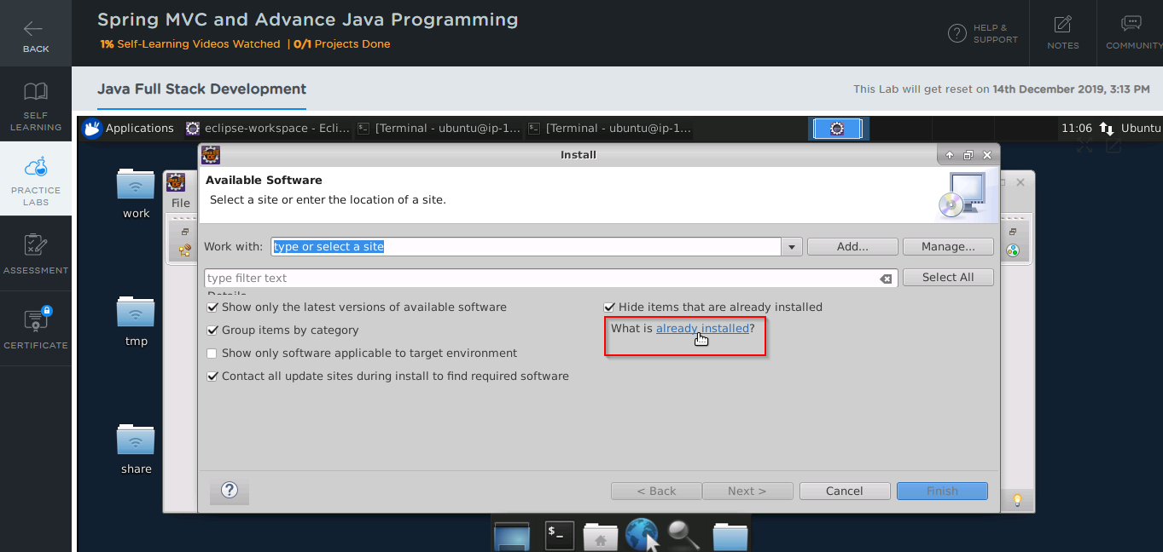

1. In the filter text field, type **Spring**. 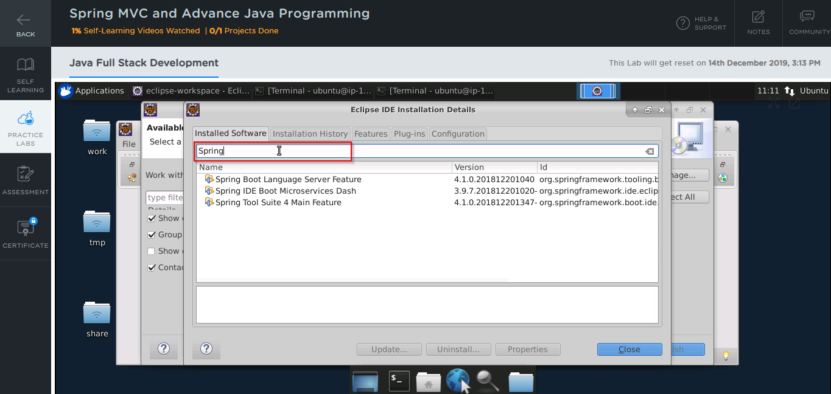

* In case Spring Packages are not installed in your practice lab, you can install them using the following steps.

1. Open Eclipse environment from the desktop, go to the **Help** tab and click on **Eclipse Marketplace**.

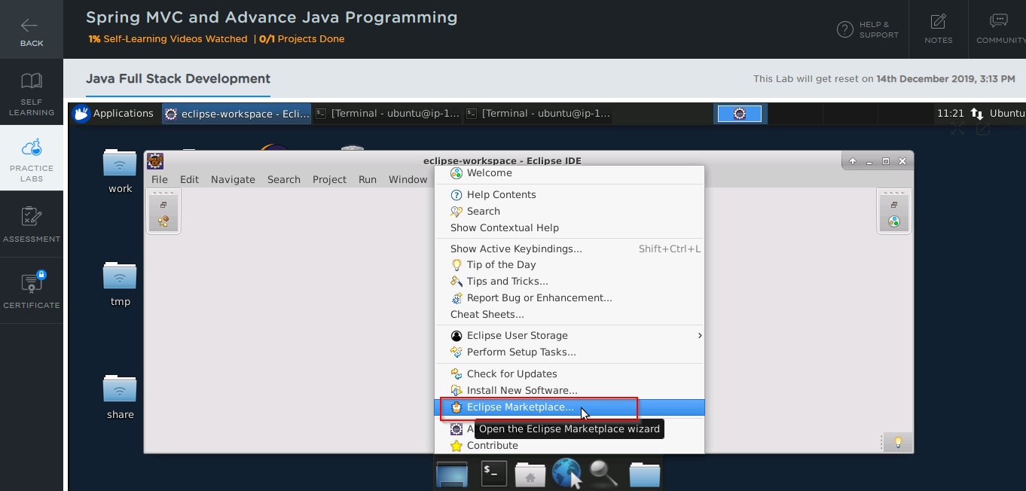

1. Type **Spring** in the **Find** field, then click on **Go**.
2. You’ll find Spring tool suite and spring boot listed. Click on the install button against the package that you want to install.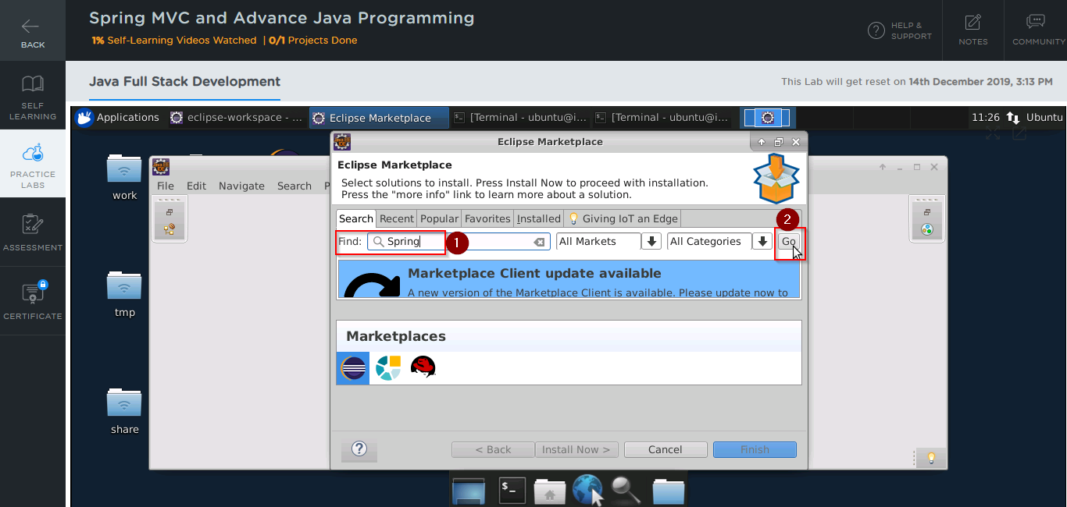

**RabbitMQ:**

* You can find it in the directory usr/lib. The same is shown in the below screenshot:

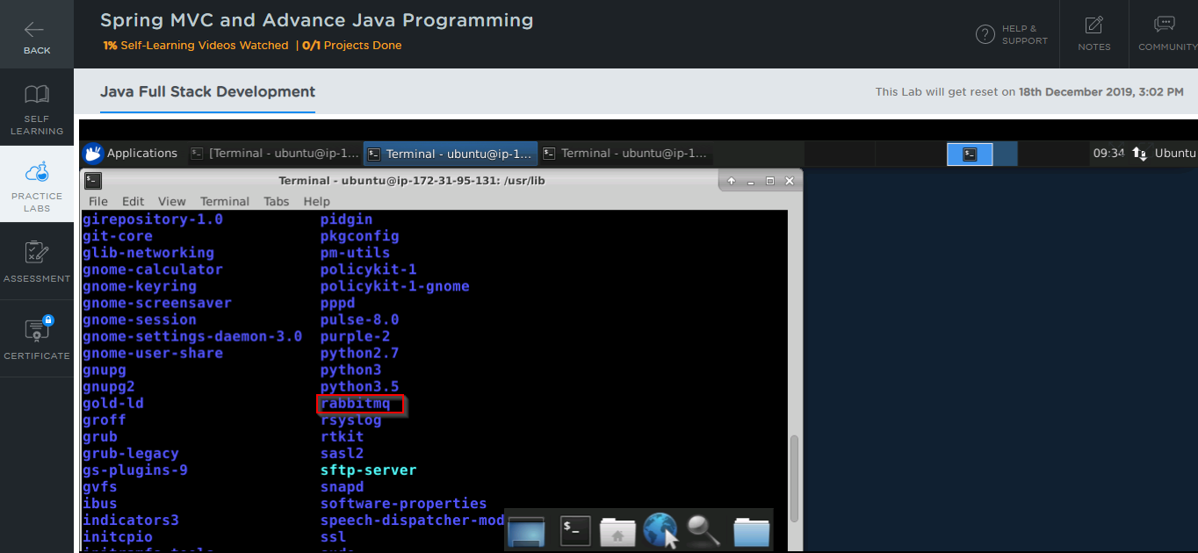

* In case RabbitMQ is not installed in your practice lab, you can install it using the commands:

*sudo apt update*

*sudo apt -y install rabbitmq-server*

**Kafka:**

You can use the following steps to install Kafka:

* Go to **https://kafka.apache.org/downloads** and download the latest binary file

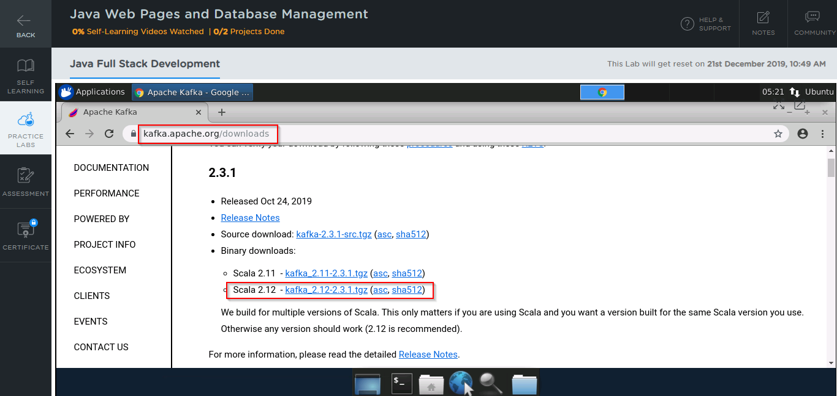

* Open the command line and navigate to the Downloads folder:

*cd Downloads*

* Use the following commands to extract files from the binary file you downloaded in the previous step:

*tar xzf kafka_2.12-2.3.1.tgz*

*mv kafka_2.12-2.3.1 /usr/local/kafka*

* Start a Zookeeper instance first using the commands:

*cd /usr/local/kafka*

*bin/zookeeper-server-start.sh config/zookeeper.properties*

* Start the Kafka server using the command:

*bin/kafka-server-start.sh config/server.properties*

**JUnit:**

* JUnit is already installed in your **Practice Labs** and you can find it in the directory */usr/share/java.*
* Use the following command to navigate to the above-mentioned directory.

*cd /usr/share/java/*

*ls*

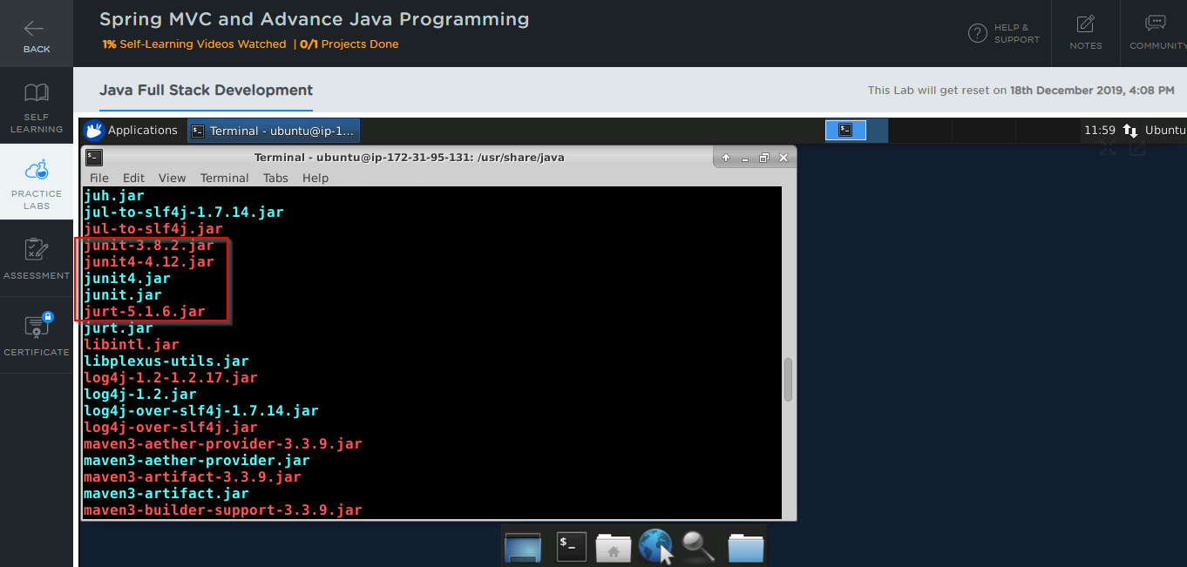

**SoapUl:**

You can use the following steps to install SoapUI:

* Go to **https://www.soapui.org/downloads** and click on **Download SoapUI open source**.

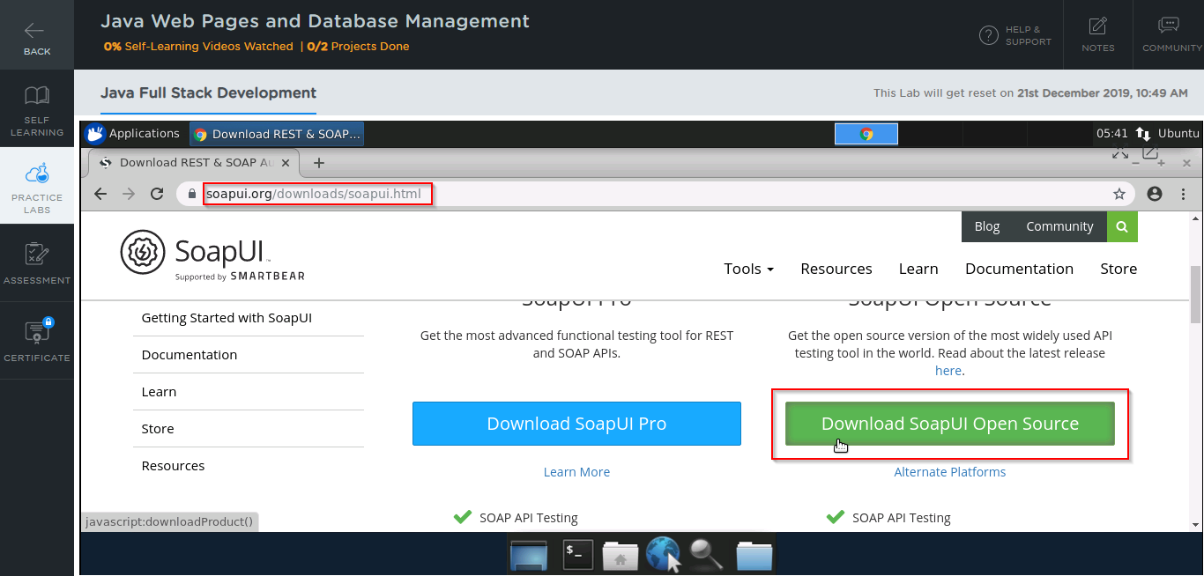

* Open the command line and navigate to the Downloads folder:

*cd Downloads*

* Run the following commands to initiate the installer:

*chmod 755 SoapUI-x64-5.5.0.sh*

*./SoapUIx-64-5.2.1.sh*

* Once the installer is initiated, click on **Next**.

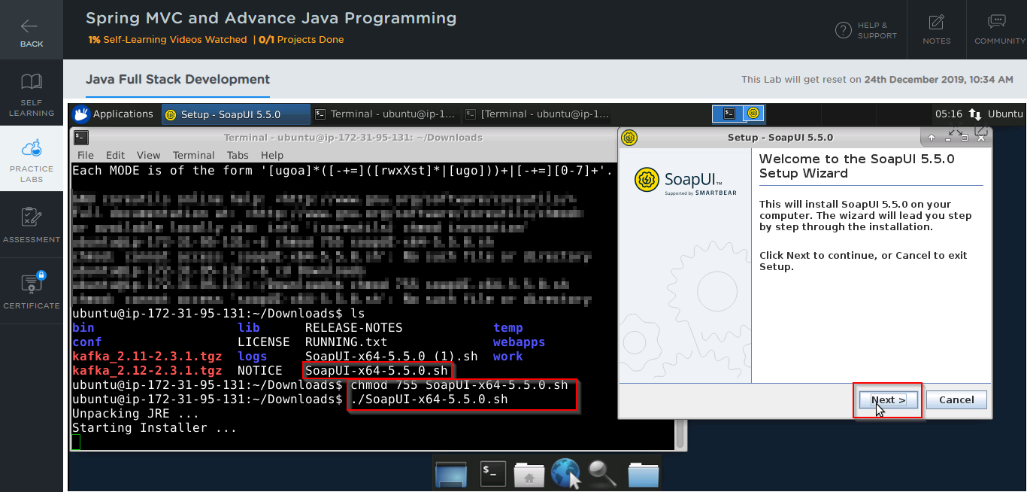

* Choose the path where you want to install SoapUI, then click on **Next**.

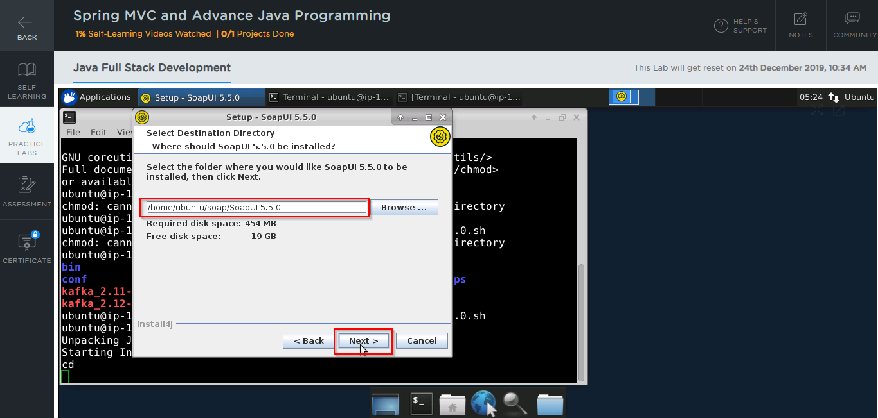

* Accept all the default settings and follow the wizard instructions to finish the installation**.**

**Jenkins:**

* Jenkins is already installed in your Practice lab. You will find it in the directory /usr/share.
* Use the following commands to navigate to the above-mentioned directory.

*cd /usr/share*

*ls*

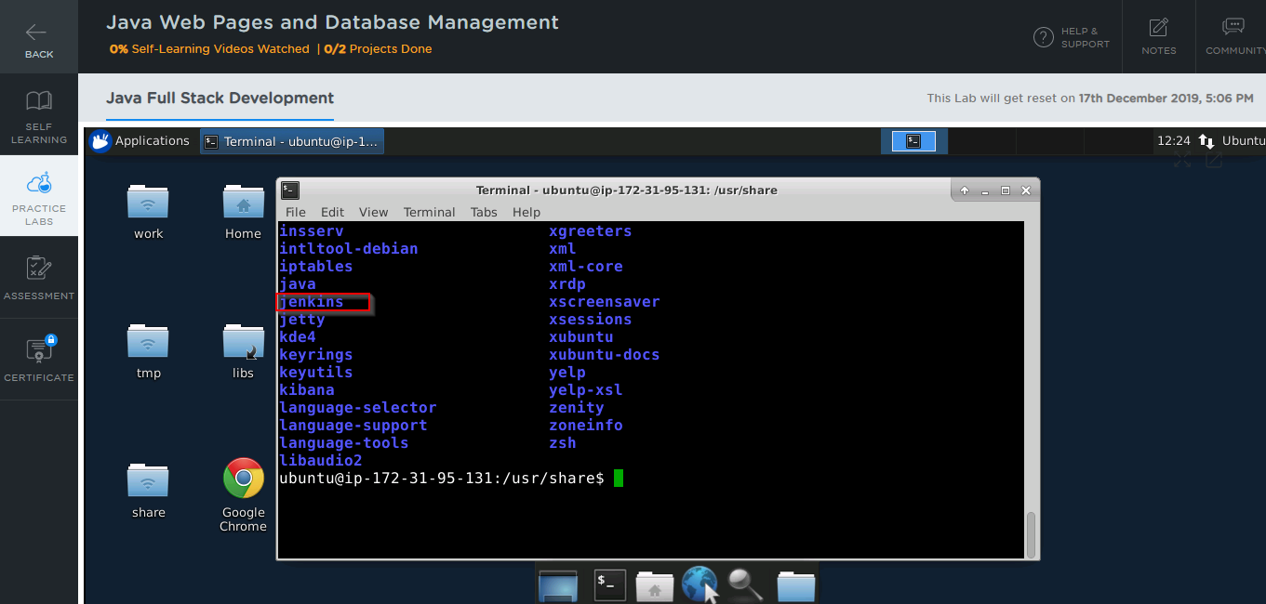

* In case Jenkins is not installed in your practice lab, you can install it using the commands:

*sudo apt update*

*sudo apt install jenkins*

**Maven:**

* Maven is already installed in your practice labs. You can use the following command to verify the installation:

*mvn -v*

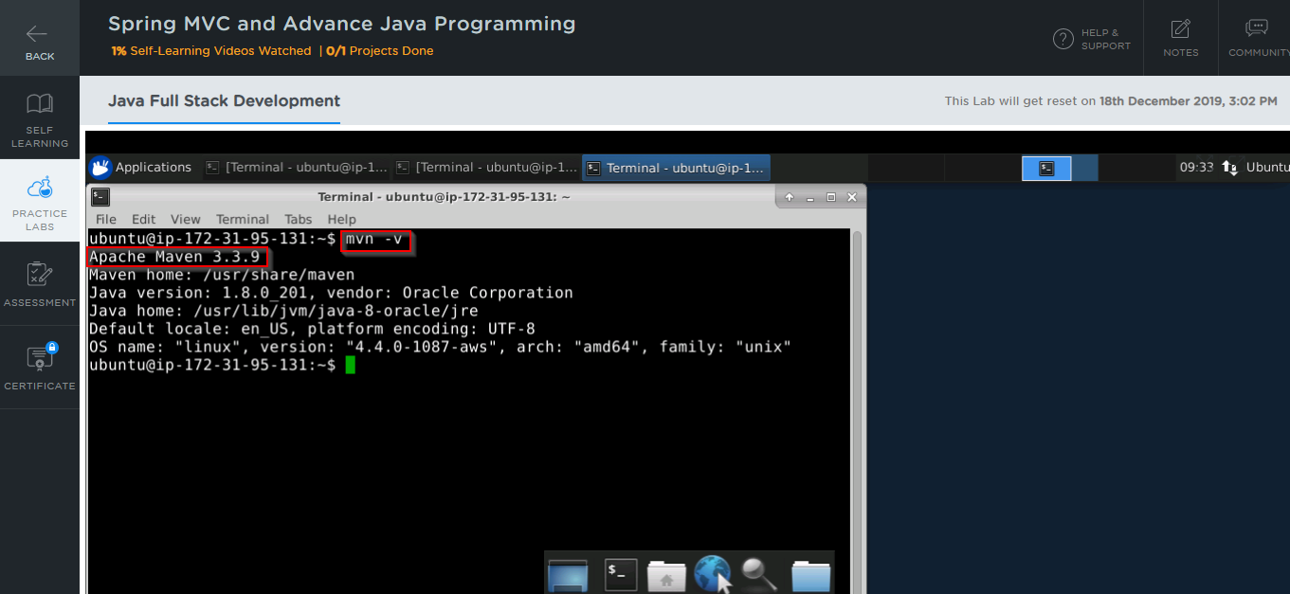

* In case Maven is not installed in your system, you can install it using the commands:

*sudo apt-get update*

*sudo apt-get install maven*